

Semester One Examination, 2021
Question/Answer booklet

MATHEMATICS
SPECIALIST
UNIT 1

If required by your examination administrator, please place your student identification label in this box
Section Two:
Calculator-assumed
WA student number: In figures

In words

Your name
Number of additional
answer booklets used
(if applicable):

Time allowed for this section
Reading time before commencing work: ten minutes
Working time: one hundred minutes

Materials required/recommended for this section
To be provided by the supervisor
This Question/Answer booklet
Formula sheet (retained from Section One)

To be provided by the candidate
Standard items: pens (blue/black preferred), pencils (including coloured), sharpener,
correction fluid/tape, eraser, ruler, highlighters

Special items: drawing instruments, templates, notes on two unfolded sheets of A4 paper, and up to three calculators, which can include scientific, graphic and Computer Algebra System (CAS) calculators, are permitted in this ATAR course examination

Important note to candidates
No other items may be taken into the examination room. It is your responsibility to ensure that you do not have any unauthorised material. If you have any unauthorised material with you, hand it to the supervisor before reading any further.

Structure of this paper

Section | Number of  questions  available | Number of  questions to  be answered | Working  time  (minutes) | Marks  available | Percentage  of  examination
Section One:  Calculator-free | 8 | 8 | 50 | 50 | 35
Section Two:  Calculator-assumed | 13 | 13 | 100 | 92 | 65
 |  |  |  | Total | 100

Markers use only
Question | Maximum | Mark
9 | 5
10 | 5
11 | 6
12 | 8
13 | 7
14 | 8
15 | 8
16 | 7
17 | 8
18 | 8
19 | 7
20 | 7
21 | 8
S2 Total | 92
S2 Wt (×0.7065) | 65%

Instructions to candidates

1. The rules for the conduct of examinations are detailed in the school handbook. Sitting this examination implies that you agree to abide by these rules.

2. Write your answers in this Question/Answer booklet preferably using a blue/black pen.
Do not use erasable or gel pens.

3. You must be careful to confine your answers to the specific question asked and to follow any instructions that are specific to a particular question.

4. Show all your working clearly. Your working should be in sufficient detail to allow your answers to be checked readily and for marks to be awarded for reasoning. Incorrect answers given without supporting reasoning cannot be allocated any marks. For any question or part question worth more than two marks, valid working or justification is required to receive full marks. If you repeat any question, ensure that you cancel the answer you do not wish to have marked.

5. It is recommended that you do not use pencil, except in diagrams.

6. Supplementary pages for planning/continuing your answers to questions are provided at the end of this Question/Answer booklet. If you use these pages to continue an answer, indicate at the original answer where the answer is continued, i.e. give the page number.

7. The Formula sheet is not to be handed in with your Question/Answer booklet.
Section Two: Calculator-assumed 65% (92 Marks)
This section has thirteen questions. Answer all questions. Write your answers in the spaces provided.

Working time: 100 minutes.

Question 9 (5 marks)
Determine $p$, the vector projection of

(a) a force of $210$ N on a bearing $022°$ onto a force of $300$ N on a bearing of $350°$. (3 marks)

(b) $v$ on $w$ where $v=\left(-16, 63\right)$ and $w=\left(24, -7\right)$. (2 marks)

Question 10 (5 marks)
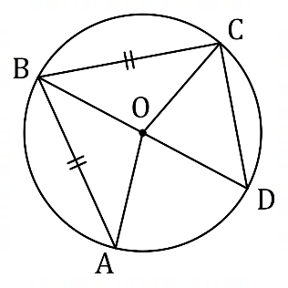
Points $A, B, C$ and $D$ lie on the circle with
centre $O$ as shown in the diagram,
where $∠A=40°$, $AB=BC$ and
$BD$ is a diameter.

(a) Determine the size of $∠AOD$. (2 marks)

(b) Prove that $ΔOAD≡ΔODC$. (3 marks)

Question 11 (6 marks)
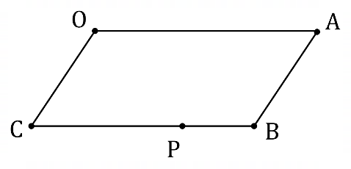
Parallelogram $OABC$ is shown where point $P$
lies on side $BC$ such that $BP:PC=1:3$.
Point $Q$, not shown, lies on diagonal $AC$
such that $AQ:QC=2:1$.

Let $\vec{OA}=a$ and $\vec{OC}=c$.

Express the following in terms of $a$ and $c$.

(a) $\vec{OB}$. (1 mark)

(b) $\vec{AQ}$. (2 marks)

(c) $\vec{QP}$. (3 marks)

Question 12 (8 marks)
(a) State whether each of the following statements are true or false, supporting each answer with an example or counterexample.

(i) A quadrilateral with four congruent sides is a square. (2 marks)

(ii) The size of one interior angle of a regular polygon with at least five sides is always obtuse. (2 marks)

(b) Consider the statement $∠A≥90°⇒∠B<90°$ that refers to angles in triangle $ABC$.

(i) Write the converse of the statement in simplest form. (1 mark)

(ii) Write the contrapositive of the statement in simplest form. (1 mark)

(iii) Briefly discuss the truth of the original statement, the converse statement, and the contrapositive statement. (2 marks)

Question 13 (7 marks)
(a) Points $P, Q$ and $R$ lie on a circle of radius $3$ cm, so that $PR$ is a diameter and $PQ=4$ cm. Determine the exact area of triangle $PQR$. (3 marks)

(b) A secant meets a circle at points $P$ and $Q$, where $PQ=8$ cm. A tangent to the same circle at point $T$ intersects the secant at point $R$, where $TR=12$ cm. Given that $QR<PR$, determine the exact distance $PR$ and the exact distance $QR$. (4 marks)

Question 14 (8 marks)
A small body is acted on by force $F_{1}$ of $85$ N on a bearing of $260°$ and by force $F_{2}$ of $45$ N on a bearing of $025°$.

(a) Sketch a diagram to show $F_{1}+F_{2}$ and their resultant $R$. (2 marks)

(b) Determine the magnitude and bearing of $R$. (4 marks)

(c) Express $R$ in component form $ai+bj$. (2 marks)

Question 15 (8 marks)
Consider the set of integers between $1000$ and $7000$ inclusive.

(a) Show that there are $546$ integers in this set that are a multiple of $11$. (2 marks)

(b) Determine the number of integers in this set that are

(i) a multiple of $11$ and a multiple of $24$. (3 marks)

(ii) not a multiple of $11$ and not a multiple of $24$. (3 marks)

Question 16 (7 marks)
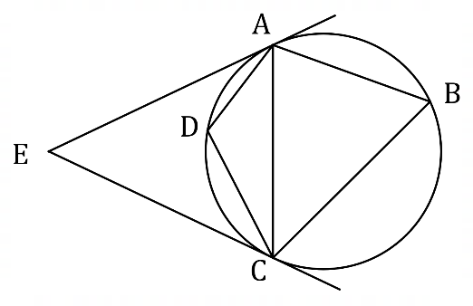
(a) The diagram shows points $A, B, C$ and $D$ on
the circumference of a circle. Tangents to
the circle from $A$ and $C$ meet at point $E$.
Given that $∠E=48°$, determine
the size of $∠B$ and the size of $∠D$.

(3 marks)

(b) In the circle shown below $∠A=33°$, $∠C=28°$ and $θ=119°$.
Prove by contradiction that $X$ is not the centre of the circle. (4 marks)

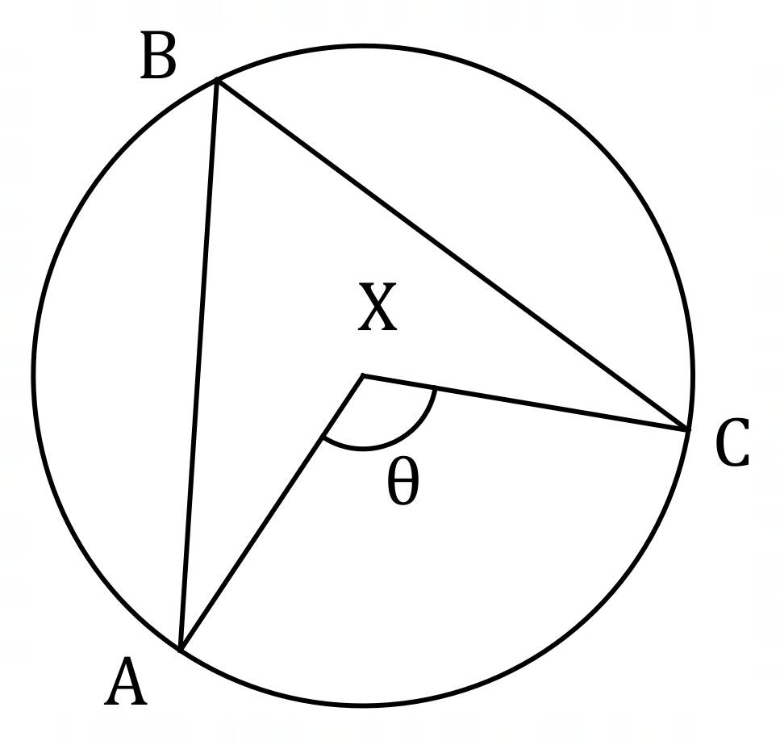

Question 17 (8 marks)
Each letter in the word ACRIMONIOUS is printed individually on a card. When cards are arranged next to each other in a line, determine the number of different permutations

(a) of all the cards. (2 marks)

(b) of all the cards where all the consonants are adjacent. (2 marks)

(c) using any $4$ of the cards. (4 marks)

Question 18 (8 marks)
Small bodies $P$ and $Q$ are moving with constant velocities $(2, -2)$ m/s and $(1, 0)$ m/s respectively.

$P$ has initial position vector $(5, 7)$ m and $Q$ has initial position vector $(-3, 13)$ m.

(a) Determine the distance between the bodies after two seconds. (3 marks)

(b) Show that the distance between the bodies after $t$ seconds is given by $\sqrt{5t^{2}+40t+100}$.
(3 marks)

(c) Prove that the bodies do not meet. (2 marks)

Question 19 (7 marks)
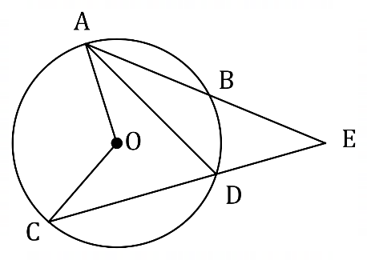
In the diagram shown, secants $AB$ and $CD$
intersect at $E$, a point outside the circle
with centre $O$

(a) Determine the size of $∠ADC$ and $∠AOC$ when $∠E=28°$ and $∠EAD=22°$. (2 marks)

(b) Prove that when secants $AB$ and $CD$ intersect at $E$, a point outside the circle with centre $O$, then $∠E=\frac{1}{2}\left(∠AOC-∠BOD\right)$. (4 marks)

(c) Determine the size of $∠E$ when $∠BOD=30°$ and $∠AOC=80°$. (1 mark)

Question 20 (7 marks)
(a) A manufacturer makes the same plastic toy figure in $12$ different colours and sells them in packs of three. The toys inside each pack are randomly chosen from the production line in such a way that all are of a different colour.
Determine the least number of packs that a retailer should buy from the manufacturer to be certain of obtaining at least four packs containing the same colour combination of toys.
(3 marks)

(b) A set of cards is numbered with all the integers from $1$ to $15$ inclusive. The cards are shuffled, placed face down and then the cards turned over one by one.
Determine how many cards must be turned over to be certain that at least one of the numbers on a face up card will be three times the number on another face up card.
(4 marks)

Question 21 (8 marks)
Harbour $Y$ lies on a bearing of $065°$ from harbour $X$ and the straight line distance between the harbours is $43$ km. Between the harbours, a steady current is moving in a south easterly direction at a speed of $1.5$ metres per second.

A boat with a cruising speed of $5.5$ metres per second is to travel from harbour $X$ to harbour $Y$ in the least possible time.

(a) Sketch a diagram, roughly to scale, to show the resultant of the sum of the displacement vectors of the boat and the current. (2 marks)

(b) Determine the bearing it should steer, to the nearest degree, and the time its journey takes, to the nearest minute. (6 marks)

Supplementary page

Question number: _________

Supplementary page

Question number: _________

Supplementary page

Question number: _________

Supplementary page

Question number: _________

© 2021 WA Exam Papers. Kennedy Baptist College has a non-exclusive licence to copy and communicate this document for non-commercial, educational use within the school. No other copying, communication or use is permitted without the express written permission of WA Exam Papers. SN245-171-2.

